Library Management System

A Desktop Application



**A PROJECT REPORT**

Under the guidance of

**MR. SANJAY PASWAN**

**MR. GOVIND KUMAR**

In Association With

**TATA MOTORS**

**OVERVIEW**

Tata Motors Limited is an Indian multinational automobile manufacturer headquartered in Mumbai, India, and part of the Tata Group. The company manufactures cars, trucks, vans, buses, and coaches.

Formerly known as Tata Engineering and Locomotive Company (TELCO), the company was founded in 1945 as a manufacturer of locomotives. The company produced its first commercial vehicle in 1954 under a partnership with Daimler-Benz AG that ended in 1969. Tata Motors entered the passenger car market in 1988 and became the first Indian manufacturer to develop a competitive domestic vehicle with the introduction of the Tata mobile and Tata Sierra in 1991. In 1998, Tata launched India's first all-original passenger car, the Indica, followed by the Tata Nano in 2008. Tata Motors acquired South Korean truck maker Daewoo Commercial Vehicle Company in 2004. Tata Motors has been the parent company of Jaguar Land Rover since it was set up to buy Jaguar Cars and Land Rover from Ford in 2008.

Tata Motors' main subsidiaries are British luxury car maker Jaguar Land Rover (maker of Jaguar and Land Rover vehicles) and South Korean commercial vehicle maker Tata Daewoo. Tata Motors has a construction machinery joint venture with Hitachi (Tata-Hitachi Construction Machinery) and a joint venture with Stellates, which produces auto parts and vehicles under the Fiat Chrysler and Tata brands. On October 12, 2021, private equity firm TPG invested $1 billion in Tata Motors' electric vehicle subsidiary.

Tata Motors has automobile and vehicle plants in India, Argentina, South Africa, the United Kingdom, and Thailand in Jamshedpur, Pant Nagar, Lucknow, Sanand, Dharwad and Pune. There are Rand centres in Pune, Jamshedpur, Lucknow, Dharwad, India, South Korea, UK, and Spain. Tata Motors is listed on the BSE (Bombay Stock Exchange) and is included in the BSE SENSEX index, as well as on the National Stock Exchange of India and the New York Stock Exchange. The company is ranked 265th on the 2019 Fortune Global 500 World's Largest Companies list.

On 17th January 2017, Natarajan Chandrasekaran was appointed Chairman of Tata Group. Tata Motors increased its UV market share by over 8% in 2019.

Story

Tata Sierra (1991–2000)

Tata Sumo (1994–2019)

Tata Motors was founded in 1945 as a locomotive manufacturer. The Tata Group entered the commercial vehicle business in 1954 after forming a joint venture with Germany's Daimler-Benz and Tata established the Daimler Truck Manufacturing Plant in Jamshedpur. In November 1954, Tata and Daimler built the first 90-100 horsepower barges. 3-5 tons at the Jamshedpur factory. After years of dominating the Indian commercial vehicle market, Tata Motors entered the passenger vehicle market in 1991 with the launch of the Tata Sierra, a sport utility vehicle based on the Tata Mobile platform. Tata then launched the Tata Estate (1992, station wagon based on the early Tata Mobile), the Tata Sumo (1994, 5-door SUV) and the Tata Safari (1998).

Tata Indica (first generation)

Tata launched Indica in 1998. Later, a new version of the car was released called the Indica V2. Tata Motors also exported cars to South Africa.

During the 2000s, Tata Motors made a series of acquisitions and partnerships, including Daewoo, a joint venture with Marco Polo of Brazil, Tata Marco Polo Buses, Jaguar Land Rover and the South Korean truck manufacturing division of Italian design and construction firm.

* MISSION

We innovate mobility solutions with passion to enhance the quality of life.

* VISION

By FY 2024, we will become the most aspirational Indian auto brand, consistently winning, by

* + Delivering superior financial returns
  + Driving sustainable mobility solutions
  + Exceeding customer expectations, and
  + Creating a highly engaged work force
* CULTURE PILLARS

BE BOLD

* + Agility
  + Risk Taking

OWN IT

* + Empowerment
  + Owner's mindset

SOLVE TOGETHER

* + Accountability
  + Collaboration

BE EMPATHETIC

* + Embracing Diversity
  + Passion for Customers

**DECLARATION**

By signing this statement, we affirm that the project work being presented in the “**LIBRARY MANAGEMENT SYSTEM**" proposed in partial completion of the internship certificate requirements at the Management Training Centre in Jamshedpur under the direction of MR. SANJAY PASWAN. This project's subject content hasn't been submitted elsewhere for a certificate of any kind, to the best of our knowledge and belief.

**Date:**

|  |  |
| --- | --- |
| **NAME** | **Name of the Institute** |
| SNEHASHISH PRAMANICK | Shivalik College of Engineering |
| SHREY KANT TIWARY | SOA-ITER |
| MOHD. NOORAIN AHMAD NIZAMI | DR B.C ROY Engineering |
| AMAAN ALI AHMAD | ARKA JAIN UNIVERSITY |
| SHRUTI KUMARI | DR B.C ROY Engineering |
| VISHAL KUMAR | SOA-ITER |
| SAYEED ANWAR | ARKA JAIN UNIVERSITY |



**CERTIFICATE**

This is to certify that the "**LIBRARY MANAGEMENT SYSTEM**" minor project proposal was completed under my supervision at the Management Training Centre by **SNEHASHISH PRAMANICK, SHREY KANT TIWARY, SHRUTI KUMARI, VISHAL KUMAR, SAYEED ANWAR, MOHD. NOORAIN AHMAD, and AMAAN ALI AHMAD**. In my view, the report meets some of the requirements for the certificate of the degree of summer internship and complies with **MTC (MANAGEMENT AND TRAINING CENTRE)** rules in its current form. To the best of my knowledge, the findings presented in this report are unique and deserving of inclusion in the current edition.

**Guide / Supervisor**

------------------------------------------------

**MR. SANJAY PASWAN**

**MR. GOVIND KUMAR**

**Project Engineer**

**Management Training Centre**

**ACKNOWLEDGEMENT**

This project was undertaken in part to fulfil a summer internship requirement and acquire real-world technical experience. Additionally, I want to thank **Mr. Sanjay Paswan**, **MR. Govind Kumar**

a **project engineer** at **MTC** in Jamshedpur, for his assistance in helping me understand the fundamental operations of the system, particularly how the internal activities of **LIBRARY MANAGEMENT SYSTEM** are carried out to maintain the system's records.

**SNEHASHISH PRAMANICK**

**SHREY KANT TIWARY**

**SHRUTI KUMARI**

**VISHAL KUMAR**

**SAYEED ANWAR**

**MOHD. NOORAIN AHMAD**

**AMAAN ALI AHMAD**

**TABLE OF CONTENTS**

Overview

Declaration

Certificate

Acknowledgement

Abstract

1.INTRODUCTION

* PROJECT AIMS AND OBJECTIVE
* BACKGROUND OF PROJECT
* OPERATION ENVIRONMENT

2.SYSTEM ANALYSIS

* SOFTWARE REQUIREMENT SPECIFICATION
* SYSTEM REQUIREMENTS
* SOFTWARE AND HARDWARE REQUIREMENTS

3.SYSTEM DESIGN

* DATA FLOW DIAGRAM

4.SYSTEM IMPLEMENTATION

* SCREEN SHORTS
* CODING

6.CONCLUSION

7.REFERENCES

**Abstract**

A project called "**Library Management System**" intends to create a computerized system to manage all the library's everyday tasks. This project has several capabilities that are typically absent from standard library management systems, such as the ability for users and administrators to log in. Additionally, it offers an admin login feature that allows the administrator to keep an eye on the entire system. It also features a feature where employees may see a list of the books they've been issued, along with the issue date and return date, and request additional books by filling out a form. The admin can create a variety of reports after logging into his account, which is his admin account, including user reports.

**Introduction**

* **PROJECT AIMS AND OBJECTIVE**

The project aims and objectives that will be achieved after completion of this project are discussed in this subchapter. The aims and objectives are as follows:

**1. Login Page:**

In this page we must fields username and password. It is having one more button for exit this application.

**2. Home Page:**

After login this one is first page. In this page we have six button and each button having different functionality.

**3. New User Page:**

In this page we have multiple fields to get details of employee having two buttons first one is used to save details and second one is used close this page.

**4. New Book Page:**

In this page we have multiple fields to get details of book, or we can say add new book in our database and having two buttons first one is used to save details and second one is used close this page.

**5. Issue Book Page:**

In this page we must enter employee ID and Book ID then we must set issue date and return date and then we will click on save. In this page there is one more button to close this page.

**6. Return Book Page:**

In this page we must enter employee ID and Book ID then we must click on search button then it will show issue and return date.

The term **"Library Management System"** refers to library systems, which are often modest or medium-sized. Using a computerized system, the administrator may keep track of a variety of transactions, including the lending out and returning of books as well as the addition of new books and employees. This system also includes modules for managing books and employees, which would track who was accessing the library and provide a thorough description of the books it held. No employee or book records will be lost with this computerized method, which typically occurs when a non-computerized system is employed. The Library Management System also has a report module. If the user is in the admin, the user can generate different kinds of reports like lists of employees registered, list of books, issue and return reports. All these modules can help librarian to manage the library with more convenience and in a more efficient way as compared to library systems which are not computerized. Reports, and book reports. in told, this.

* **BACKGROUND OF PROJECT**

Library Management System is an application which refers to. Library systems which are generally small or medium in size. It is used by librarian to manage the library using a computerized. System where he/she can record various transactions like issue. Of books, return of books, addition of new books, addition of new students etc. Books and student maintenance modules are also included in. This system which would keep track of the students using the library and a detailed description about the books a library contains. With this computerized system there will be no loss of book record or member record which generally happens when a non-computerized system is used. In addition, report module is also included in Library. Management System. If user’s position is admin, the user can generate different kinds of reports like lists of students registered, list of books, issue and return reports. All these modules can help librarian to manage the library with more convenience and in a more efficient way as compared to library systems which are not computerized.

* **OPERATION ENVIRONMENT**

|  |  |
| --- | --- |
| PROCESSOR | INTEL CORE PROCESSOR OR BETTER |
|  | PERFORMANCE |
|  |  |
| OPERATING SYSTEM | WINDOWS 10, WINDOWS 11 |
|  |  |
| MEMORY | 2 GB RAM OR MORE |
|  |  |
| HARD DISK SPACE | MINIMUM 3 GB FOR DATABASE USAGE FOR |
|  | FUTURE |
|  |  |
| DATA BASE | MY SQL |
|  |  |

**SYSTEM ANALYSIS**

This chapter will explore and analyse the process of development.

of the Library Management System, including a comparison of the proposed and existing systems and the software requirement specification (SRS). Before the creating process begins, the SRS component includes both functional and non-functional requirements to provide a thorough description and overview of system needs. Additionally, comparing the existing and proposed systems shows how the suggested system will be more effective than the current one.

* **SOFTWARE REQUIREMENT SPECIFICATION**  
   GENERAL DESCRIPTION

**PRODUCT DESCRIPTION**

Using a computerized system called a library management system, a librarian can electronically manage the day-to-day operations of their library. It lessens the possibility of paperwork being time-consuming, misplaced, or damaged. It can assist the user in more efficiently and quickly managing the transaction or record.

**CONFLICT STATEMENT**

The issue that existed before the computerized system includes:

• File gone When a computerized system is not used, files are lost frequently due to the human environment. There may occasionally be a loss of records because of human error.

• Damaged file Without a computerized system, files are frequently lost because of mishaps like members accidentally dropping water on them. In addition, some natural disasters like fires or floods

• Record searches are challenging without a computerized system. If there are a lot of records, it is usually tough to look through them.

• Space-consuming If no computerized system is used, as the number of records grows, so does the need for physical storage of files and records.

• Expensive since each record must be added by hand because there is no computerized system for this, which drives up the cost of running the library.

SYSTEM OBJECTIVE

• An improvement in performance and control. The system was created to address the current issues and challenges facing libraries. The system has bug-free functionality and can add and validate users.

• Lower overall costs as less labour will be needed to maintain the library after the computerized system is put in place. Saving time with just a few mouse clicks and a few search terms, a librarian can quickly find a record, saving him important time.

* **SYSTEM REQUIREMENTS**

NON-FUNCTIONAL REQUIREMENTS

**Product Requirements**

* **EFFICIENCY REQUIREMENT**

When a library management system will be implemented librarian and user will easily access library as searching will be very faster.

* **RELIABILITY REQUIREMENT**

The system should accurately perform member registration, member validation, report generation, and search.

* **USABILITY REQUIREMENT**

The system is designed for a user-friendly environment so that student and staff of library can perform the various tasks easily and in an effective way.

* **REQUIREMENT OF ORGANISATION**

The entire system is implemented using java swing in the front end with MySQL as the server, which will be used for database connectivity. MySQL is also used in the backend, or database development, of the system. It operates with the Apache NetBeans IDE.

FUNCTIONAL REQUIREMENTS

* **USER LOGIN FOR A NORMAL USER**

Feature description

The user uses this functionality to log into the system. The user id must be entered.

they must first provide a username and password before being admitted. The user id and password will be checked, and if an invalid id is present, the user will not be permitted to enter the system.

Functional prerequisites

When users register, they provide their user id.

-The system must only permit users with valid identification and passwords to access it.

-The system conducts an authorization process to determine which user level has access.

-The user must have the option to log out once they are done using the system.

* **NEW USER REGISTRATION**

All users have access to this function, which allows them to create accounts for new users.

Functional specifications

-System must be capable of information verification

-The system must be able to erase data if it is incorrect.

* **ADD A NEW BOOK**

New books can be added to the library using this function.

Functional specifications

The system must have the ability to check data and record the number of copies in a database.

- The system must be able to prevent two books from sharing the same book id.

* **ISSUE BOOKS AND RETURN FEATURE DESCRIPTION**

This feature enables users to issue, receive, and see reports for books issued.

Functional specifications

-System must be capable of adding issue data to databases.

A lot of books must be updated by the system.

Before issuing, the system must be able to check to see if the book is available.

System should be able to enter issue and return date information.

* **SOFTWARE AND HARDWARE REQUIREMENTS**

This section describes the software and hardware requirements of the system.

**WHAT SOFTWARE IS NECESSARY?**

• Operating system – Windows is utilized because it is dependable, supports more functions, and is easier to use.

• MySQL database: MySQL is used as a database because it is simple to manage and retrieve entries using straightforward English-language queries that are simple to read and write.

• Development tools and programming language: The entire code is written in Java Swing, and NetBeans and MySQL are developed for server-side scripting.

**REQUIREMENTS FOR HARDWARE**

Because it is faster than other CPUs and offers dependable and steady performance, Intel Core i5 11th Generation is utilized as a processor. This allows us to run our PC for extended periods. With the help of this processor, we may continue working on our project without any concerns. RAM 1 GB is used as it will provide fast reading and writing capabilities and will in turn support in processing.

**SOFTWARE TOOL USED**

To create a library management system using NetBeans and Java Swing, you can follow these steps:

Install NetBeans: Download and install the latest version of NetBeans IDE from the official website (https://netbeans.apache.org/).

* **Create a new Java project:** Launch NetBeans and select "File" -> "New Project" from the menu. In the "New Project" dialog, choose "Java" category and select "Java Application". Click "Next" and give your project a name and location. Click "Finish" to create the project.
* **Design the user interface:** In the NetBeans IDE, you can use the drag-and-drop interface builder to design the user interface using Java Swing components. Open the form designer by double-clicking on the project's main class or by right-clicking on the project and selecting "New" -> "Frame Form". You can then drag and drop components like buttons, labels, text fields, and tables onto the form to create the desired layout.
* **Implement functionality:** Write the Java code to implement the functionality of your library management system. For example, you'll need to handle events like button clicks, perform database operations (e.g., storing book information, retrieving borrower details), and update the user interface accordingly.
* **Test and debug:** Use NetBeans' built-in debugging tools to test and debug your application. You can set breakpoints, step through the code, inspect variables, and track the flow of execution to identify and fix any issues.
* **Build and deploy:** Once your library management system is ready, you can build the project by selecting "Build" -> "Build Project" from the NetBeans menu. NetBeans will generate a runnable JAR file that you can distribute and run on other computers.

Remember to use appropriate design patterns and best practices when developing your library management system, such as separating the user interface logic from the data access layer, following the Model-View-Controller (MVC) pattern, and implementing error handling and validation.

It's worth noting that there are other IDEs and tools available for Java development, such as Eclipse and IntelliJ IDEA, which you can also use to create a library management system using Java Swing. The steps may vary slightly, but the core c.

**BACK END-** The back end is designed using MySQL which is used to design the databases MySQL is a popular choice for designing databases in a desktop-based library management system. It is a relational database management system (RDBMS) that provides a robust and scalable solution for storing and managing data.

In the back end of the library management system, MySQL can be used to create the necessary database tables to store information about books, library members, transactions, and other relevant data. Here are some of the steps involved in designing the back end using MySQL:

* **Database Design:** Identify the entities and their relationships in the library management system. Create a conceptual data model that represents these entities and their attributes. Convert the conceptual model into a logical model using an entity-relationship diagram (ERD). Based on the logical model, create the necessary tables in MySQL.
* **Table Creation:** Use the MySQL Data Definition Language (DDL) to create the tables in the MySQL database. Define the appropriate data types for each column in the table, such as VARCHAR for storing text, INT for integers, DATE for dates, etc. Specify primary keys, foreign keys, and other constraints as needed.
* **Table Relationships:** Establish relationships between the tables using foreign keys. For example, you can create a foreign key in the "Transactions" table that references the "Books" table to associate each transaction with a specific book.
* **Indexing:** Identify columns that are frequently used in search queries and add indexes to improve query performance. Indexing allows the database to quickly locate the desired data by creating a separate data structure that maps the indexed column values to their corresponding rows.
* **Stored Procedures and Functions:** Use MySQL's stored procedures and functions to encapsulate complex queries or business logic. This can help improve performance and maintainability by centralizing common database operations.
* **Data Population:** Once the tables are created, populate them with initial data, such as sample books, library members, etc. This can be done manually or by importing data from external sources.
* **Data Manipulation:** Use MySQL's Data Manipulation Language (DML) statements like INSERT, UPDATE, DELETE, and SELECT to manage and retrieve data from the tables. These statements allow you to add, modify, delete, and query records in the database.

By leveraging MySQL as the back-end database, you can efficiently store and manage the library management system's data, enabling effective information retrieval and data manipulation for the desktop-bas.

**DATA FLOW DIAGRAM**

**What is data flow diagram?**

A Data Flow Diagram (DFD) is a traditional visual representation of the information flows within a system. A neat and clear DFD can depict the right amount of the system requirement graphically. It can be manual, automated, or a combination of both.

It shows how data enters and leaves the system, what changes the information, and where data is stored.

The objective of a DFD is to show the scope and boundaries of a system. It may be used as a communication tool between a system analyst and any person who plays a part in the order that acts as a starting point for redesigning a system. The DFD is also called as a data flow graph or bubble chart.

The following observations about DFDs are essential:

1.All names should be unique. This makes it easier to refer to elements in the DFD.

2.Remember that DFD is not a flow chart. Arrows is a flow chart that represents the order of events; arrows in DFD represents flowing data. A DFD does not involve any order of events.

3.Suppress logical decisions. If we ever have the urge to draw a diamond-shaped box in a DFD, suppress that urge! A diamond-shaped box is used in flow charts to represents decision points with multiple exists paths of which the only one is taken. This implies an ordering of events, which makes no sense in a DFD.

4.Do not become bogged down with details. Defer error conditions and error handling until the end of the analysis.

Standard symbols for DFDs are derived from the electric circuit diagram analysis and are shown in fig:

**Circle:** A circle (bubble) shows a process that transforms data inputs into data outputs.

**Data Flow:** A curved line shows the flow of data into or out of a process or data store.

**Data Store:** A set of parallel lines shows a place for the collection of data items. A data store indicates that the data is stored which can be used at a later stage or by the other processes in a different order. The data store can have an element or group of elements.

**Source or Sink:** Source or Sink is an external entity and acts as a source of system inputs or sink of system outputs. Ed application. concepts and principles remain.

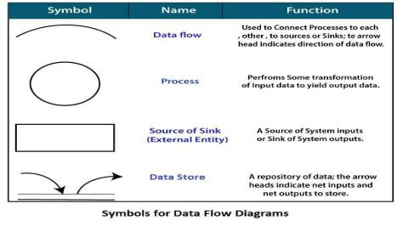

**Zero Level Data Flow Diagram [ 0 Level DFD] OF Library Management System:**

This is the Zero Level DFD of Library Management System, where we have elaborated the high-level process of Library Management. It's a basic overview of the Library Management System or process being analysed or modelled. It's designed to be an at-a-glance view of Punisher. Employee showing the system as a single high-level process with a relationship to external Library, Book, and Issue Book entities. It should be easily understood by a wide audience, including Library, Issue Book In zero-level DFD of Library Management System, we have described the high-level flow of the Library Management system.

High-Level Entities and Process Mow of Library Management System:

• Managing all the Library • Managing all the Book • Managing all the Issue Book • Managing all the Authors • •Managing all the Employee • Managing all the Stu

Login Management

Authors Management

Library Management

System User Management

Employee Management

Books Management

**First Level Data Flow Diagrams (1st Level DFD) OF Library Management System:**

First Level DFD (1st Level) of the Library Management System shows how the system is divided into sub-systems (processes), each of which deals with one or more of the data flows to or from an external agent, and which together provides all the functionality of the Library Management System. It also identifies internal data stores of Students, Employees, Authors, and Issue Books that must be present For the Library Management system to do its job and shows the flow of data between the various parts of the Library, Issue Book, Employee. DFD Level 1 provides a more detailed breakout of pieces of the 1st level DFD. You will highlight the main functional he's of Library Management.

Main entities and output of First Level DFD (1st Level DFD]:

• Processing Library records and generating reports of all Library • Processing Book records and generating reports of all Book • Processing Issue Book records and generating reports of all Issue Book • Processing Author's records and generating reports of all Authors • Processing Employee records and generate report of all Employee.

Generate Employee Report

Generate Books Report

Check User Login Details

Generate Book Issue Report

Generate library Report

Employee Management

Books Management

Books Issue Management

Login Management

Library Management

**Second Level Data Flow Diagram (2nd Level DFD] OF Library Management System:**

DFD Level 2 goes one step deeper into the pads of Level 1 of Library Management. It may require more functionalities of Library Management to reach the necessary level of detail about the Library Management functioning. First Level DFD (1st Level) of the Library Management System shows how the system is divided into sub-systems (processes). The 2nd Level DFD contains more details of Student, Employ, Authors, Issue Book, Book, and Library.

Low-level functionalities of the Library Management System

• Admin login to the system and manage all the functionalities of Library Management System • Admin can add, edit, delete, and view the records of Library Issue Book• Admin can manage all the details of Book. Authors. Employee • Admin can also generate reports of Library, Book. Issue Book, Authors, Employee • Admin can search the details of Book, Employee • Admin can apply different levels of filters on report of Library, Authors • Admin can track the detailed information of Book, Issue Book, Authors.

Manage Report

Manage Employee Details

Manage Category Details

Manage Author Details

Manage Issue Book Details

Manage Book Details

Mange Library Details

Manage System Admins

Admin

**System Implementation**

**Screen Shorts**

**User Interface**

**Admin Login Page**

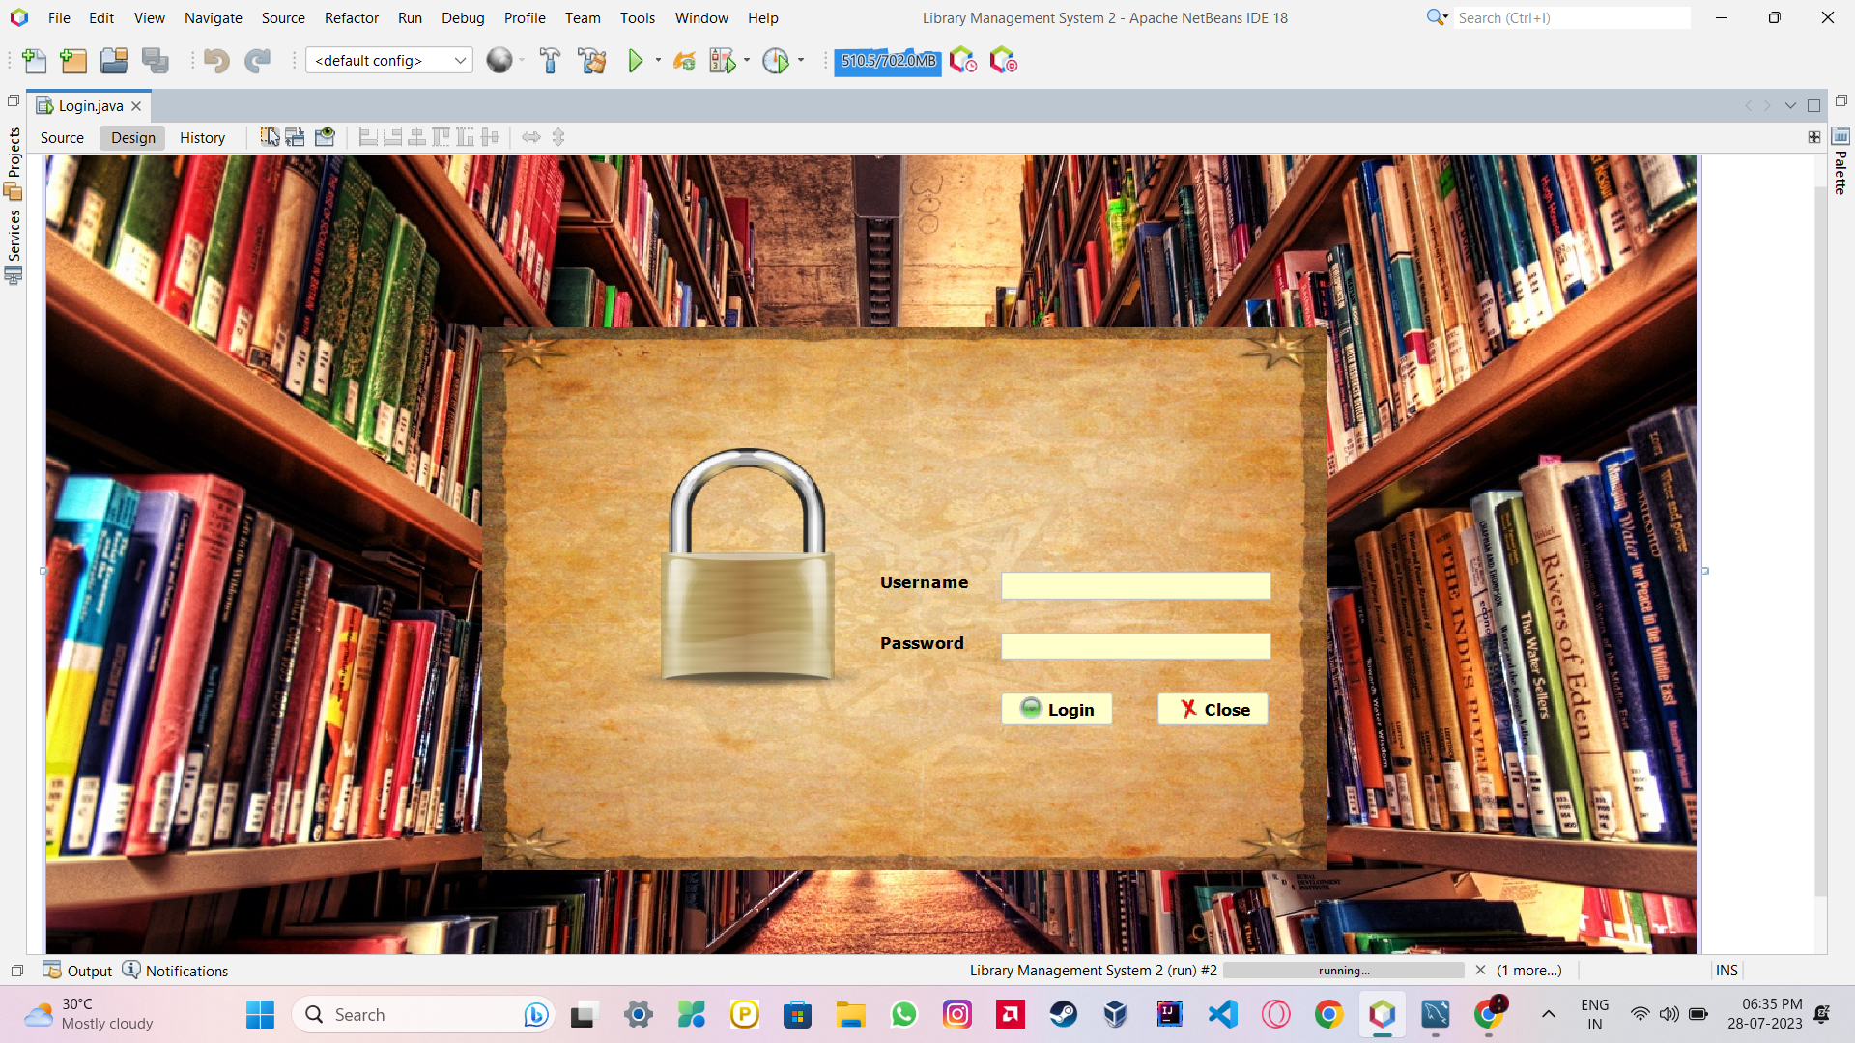

**Home Page**

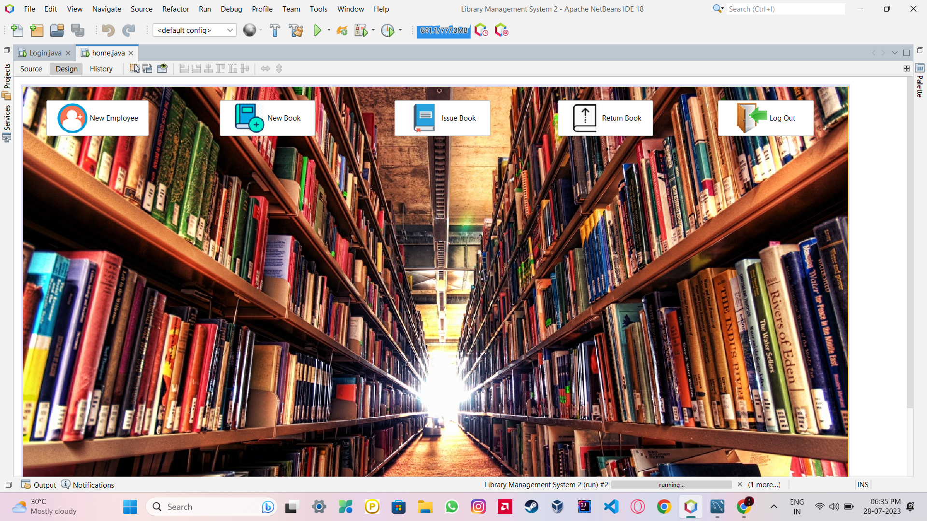

**New Employee Page**

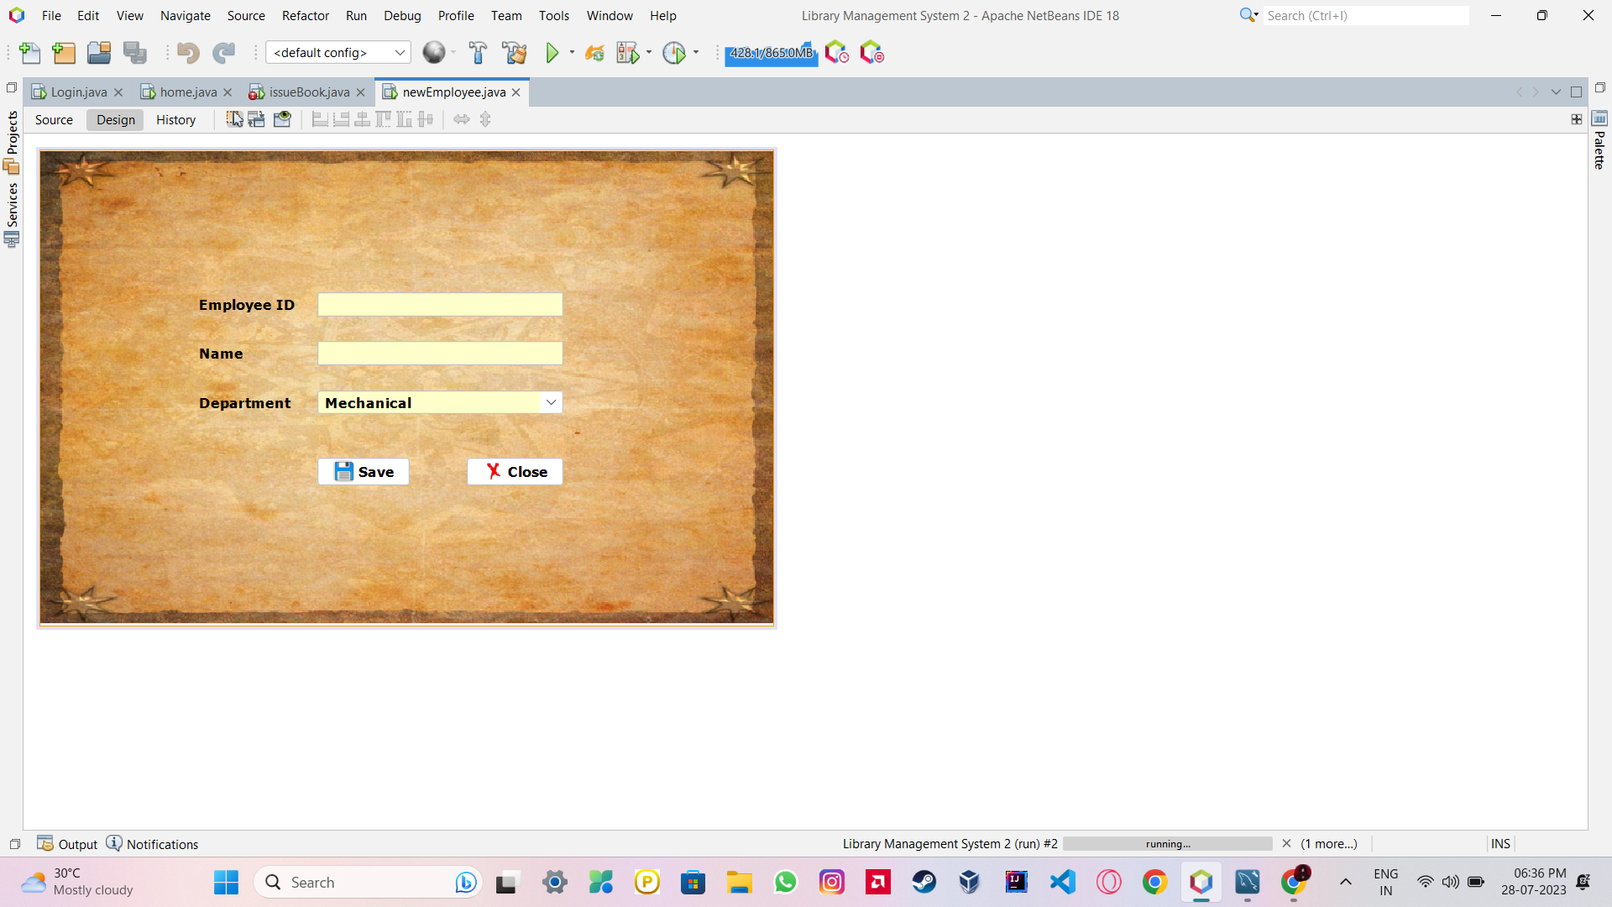

**New Book Page**

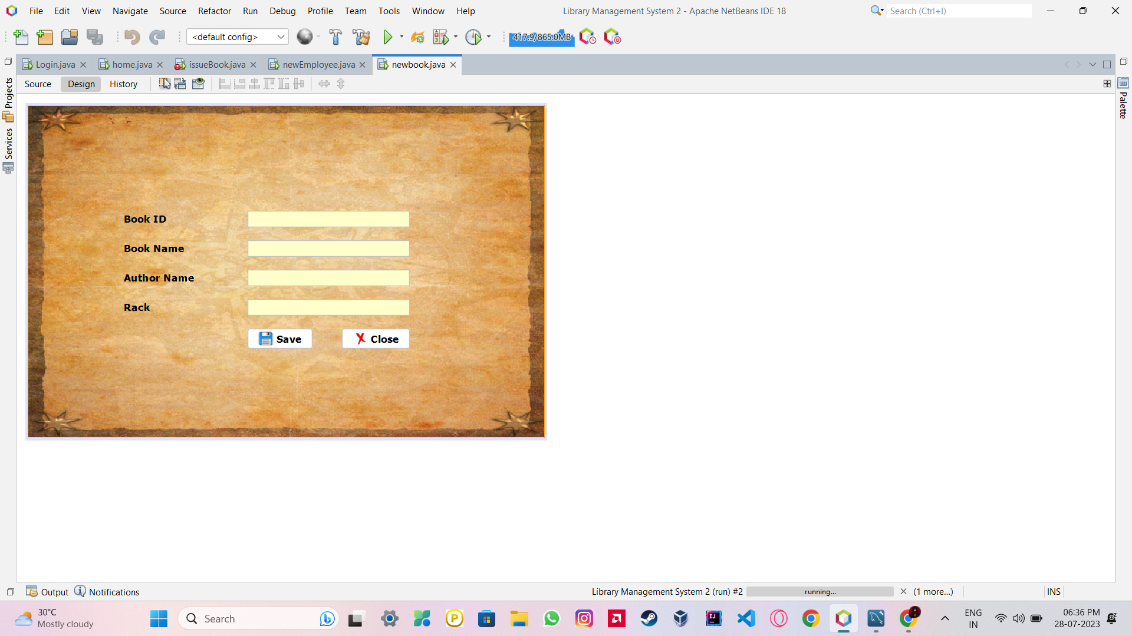

**Issue Book Page**

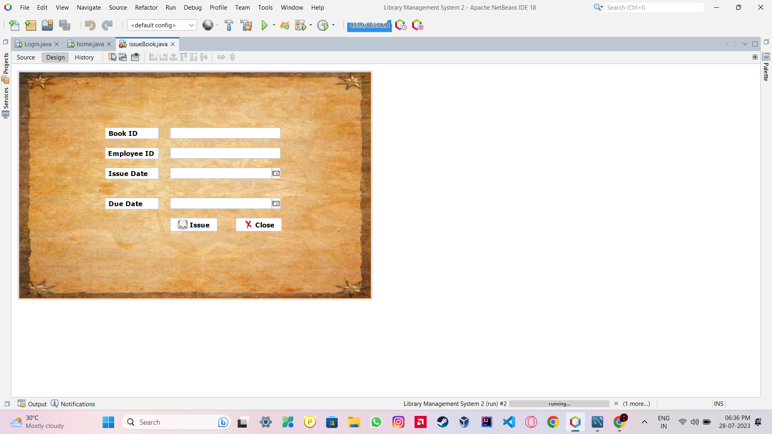

**Return Book Page**

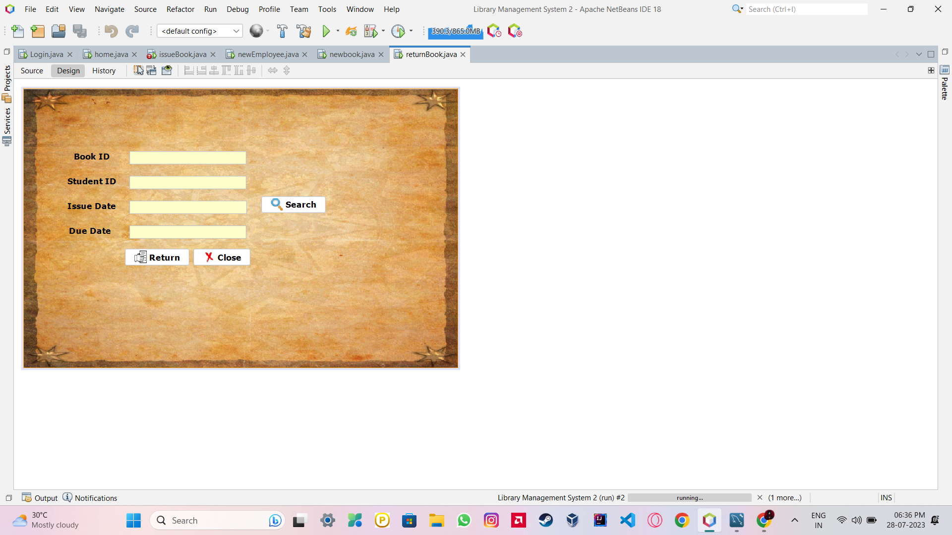

**Database Page**

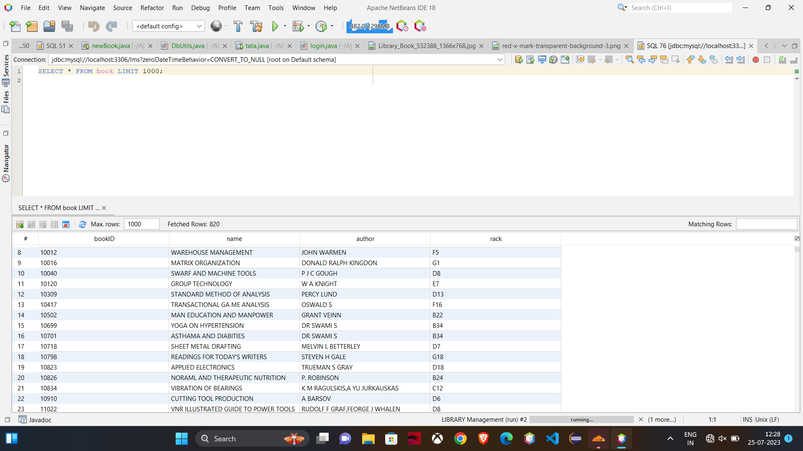

**Coding**

**Admin Page**

**/\***

**\* Click nbfs://nbhost/SystemFileSystem/Templates/Licenses/license-default.txt to change this license**

**\* Click nbfs://nbhost/SystemFileSystem/Templates/GUIForms/JFrame.java to edit this template**

**\*/**

**import javax.swing.JFrame;**

**import javax.swing.JOptionPane;**

**public class tata extends javax.swing.JFrame {**

**/\*\***

**\* Creates new form tata**

**\*/**

**public tata() {**

**initComponents();**

**setExtendedState(JFrame.MAXIMIZED_BOTH);**

**}**

**/\*\***

**\* This method is called from within the constructor to initialize the form.**

**\* WARNING: Do NOT modify this code. The content of this method is always**

**\* regenerated by the Form Editor.**

**\*/**

**@SuppressWarnings("unchecked")**

**// <editor-fold defaultstate="collapsed" desc="Generated Code">**

**private void initComponents() {**

**jLabel1 = new javax.swing.JLabel();**

**jLabel2 = new javax.swing.JLabel();**

**jTextField1 = new javax.swing.JTextField();**

**jPasswordField1 = new javax.swing.JPasswordField();**

**jButton1 = new javax.swing.JButton();**

**jButton2 = new javax.swing.JButton();**

**jLabel3 = new javax.swing.JLabel();**

**jLabel4 = new javax.swing.JLabel();**

**setDefaultCloseOperation(javax.swing.WindowConstants.EXIT_ON_CLOSE);**

**getContentPane().setLayout(new org.netbeans.lib.awtextra.AbsoluteLayout());**

**jLabel1.setFont(new java.awt.Font("Segoe UI", 1, 14)); // NOI18N**

**jLabel1.setText("User Name");**

**getContentPane().add(jLabel1, new org.netbeans.lib.awtextra.AbsoluteConstraints(650, 300, 80, -1));**

**jLabel2.setFont(new java.awt.Font("Segoe UI", 1, 14)); // NOI18N**

**jLabel2.setText("Password");**

**getContentPane().add(jLabel2, new org.netbeans.lib.awtextra.AbsoluteConstraints(660, 350, 69, -1));**

**jTextField1.setBackground(new java.awt.Color(204, 255, 255));**

**jTextField1.setFont(new java.awt.Font("Segoe UI", 1, 14)); // NOI18N**

**getContentPane().add(jTextField1, new org.netbeans.lib.awtextra.AbsoluteConstraints(730, 290, 234, -1));**

**jPasswordField1.setBackground(new java.awt.Color(204, 255, 255));**

**getContentPane().add(jPasswordField1, new org.netbeans.lib.awtextra.AbsoluteConstraints(730, 350, 234, -1));**

**jButton1.setFont(new java.awt.Font("Segoe UI", 1, 12)); // NOI18N**

**jButton1.setText("Login");**

**jButton1.addActionListener(new java.awt.event.ActionListener() {**

**public void actionPerformed(java.awt.event.ActionEvent evt) {**

**jButton1ActionPerformed(evt);**

**}**

**});**

**getContentPane().add(jButton1, new org.netbeans.lib.awtextra.AbsoluteConstraints(760, 400, -1, -1));**

**jButton2.setFont(new java.awt.Font("Segoe UI", 1, 14)); // NOI18N**

**jButton2.setText("Close");**

**jButton2.addActionListener(new java.awt.event.ActionListener() {**

**public void actionPerformed(java.awt.event.ActionEvent evt) {**

**jButton2ActionPerformed(evt);**

**}**

**});**

**getContentPane().add(jButton2, new org.netbeans.lib.awtextra.AbsoluteConstraints(870, 400, -1, -1));**

**jLabel3.setFont(new java.awt.Font("Segoe UI", 1, 14)); // NOI18N**

**jLabel3.setText("Admin Login");**

**getContentPane().add(jLabel3, new org.netbeans.lib.awtextra.AbsoluteConstraints(790, 240, -1, -1));**

**jLabel4.setFont(new java.awt.Font("Segoe UI", 1, 14)); // NOI18N**

**jLabel4.setIcon(new javax.swing.ImageIcon(getClass().getResource("/Login background.PNG"))); // NOI18N**

**getContentPane().add(jLabel4, new org.netbeans.lib.awtextra.AbsoluteConstraints(0, 0, 1460, -1));**

**pack();**

**}// </editor-fold>**

**private void jButton1ActionPerformed(java.awt.event.ActionEvent evt) {**

**// TODO add your handling code here:**

**if(jTextField1.getText().equals("admin")&& jPasswordField1.getText().equals("admin"))**

**{**

**setVisible(false);**

**new home().setVisible(true);**

**}**

**else**

**JOptionPane.showMessageDialog(null,"Incorrect Username or Password");**

**}**

**private void jButton2ActionPerformed(java.awt.event.ActionEvent evt) {**

**// TODO add your handling code here:**

**System.exit(0);**

**}**

**/\*\***

**\* @param args the command line arguments**

**\*/**

**public static void main(String args[]) {**

**/* Set the Nimbus look and feel */**

**//<editor-fold defaultstate="collapsed" desc=" Look and feel setting code (optional) ">**

**/* If Nimbus (introduced in Java SE 6) is not available, stay with the default look and feel.**

**\* For details see http://download.oracle.com/javase/tutorial/uiswing/lookandfeel/plaf.html**

**\*/**

**try {**

**for (javax.swing.UIManager.LookAndFeelInfo info : javax.swing.UIManager.getInstalledLookAndFeels()) {**

**if ("Nimbus".equals(info.getName())) {**

**javax.swing.UIManager.setLookAndFeel(info.getClassName());**

**break;**

**}**

**}**

**} catch (ClassNotFoundException ex) {**

**java.util.logging.Logger.getLogger(tata.class.getName()).log(java.util.logging.Level.SEVERE, null, ex);**

**} catch (InstantiationException ex) {**

**java.util.logging.Logger.getLogger(tata.class.getName()).log(java.util.logging.Level.SEVERE, null, ex);**

**} catch (IllegalAccessException ex) {**

**java.util.logging.Logger.getLogger(tata.class.getName()).log(java.util.logging.Level.SEVERE, null, ex);**

**} catch (javax.swing.UnsupportedLookAndFeelException ex) {**

**java.util.logging.Logger.getLogger(tata.class.getName()).log(java.util.logging.Level.SEVERE, null, ex);**

**}**

**//</editor-fold>**

**/* Create and display the form */**

**java.awt.EventQueue.invokeLater(new Runnable() {**

**public void run() {**

**new tata().setVisible(true);**

**}**

**});**

**}**

**// Variables declaration - do not modify**

**private javax.swing.JButton jButton1;**

**private javax.swing.JButton jButton2;**

**private javax.swing.JLabel jLabel1;**

**private javax.swing.JLabel jLabel2;**

**private javax.swing.JLabel jLabel3;**

**private javax.swing.JLabel jLabel4;**

**private javax.swing.JPasswordField jPasswordField1;**

**private javax.swing.JTextField jTextField1;**

**// End of variables declaration**

**}**

**Home Page**

**\***

**\* Click nbfs://nbhost/SystemFileSystem/Templates/Licenses/license-default.txt to change this license**

**\* Click nbfs://nbhost/SystemFileSystem/Templates/GUIForms/JFrame.java to edit this template**

**\*/**

**public class home extends javax.swing.JFrame {**

**/\*\***

**\* Creates new form home**

**\*/**

**public home() {**

**initComponents();**

**setExtendedState(MAXIMIZED_BOTH);**

**}**

**/\*\***

**\* This method is called from within the constructor to initialize the form.**

**\* WARNING: Do NOT modify this code. The content of this method is always**

**\* regenerated by the Form Editor.**

**\*/**

**@SuppressWarnings("unchecked")**

**// <editor-fold defaultstate="collapsed" desc="Generated Code">**

**private void initComponents() {**

**jButton1 = new javax.swing.JButton();**

**jButton2 = new javax.swing.JButton();**

**jButton3 = new javax.swing.JButton();**

**jButton4 = new javax.swing.JButton();**

**jButton5 = new javax.swing.JButton();**

**jButton6 = new javax.swing.JButton();**

**jLabel2 = new javax.swing.JLabel();**

**setDefaultCloseOperation(javax.swing.WindowConstants.EXIT_ON_CLOSE);**

**setMaximumSize(new java.awt.Dimension(1400, 768));**

**setPreferredSize(new java.awt.Dimension(1366, 768));**

**getContentPane().setLayout(new org.netbeans.lib.awtextra.AbsoluteLayout());**

**jButton1.setIcon(new javax.swing.ImageIcon(getClass().getResource("/member-add-on-300x300.png"))); // NOI18N**

**jButton1.setText("New Employee");**

**jButton1.setMaximumSize(new java.awt.Dimension(159, 59));**

**jButton1.setMinimumSize(new java.awt.Dimension(159, 59));**

**jButton1.setPreferredSize(new java.awt.Dimension(159, 59));**

**jButton1.addActionListener(new java.awt.event.ActionListener() {**

**public void actionPerformed(java.awt.event.ActionEvent evt) {**

**jButton1ActionPerformed(evt);**

**}**

**});**

**getContentPane().add(jButton1, new org.netbeans.lib.awtextra.AbsoluteConstraints(70, 20, 171, 86));**

**jButton2.setIcon(new javax.swing.ImageIcon(getClass().getResource("/New book.png"))); // NOI18N**

**jButton2.setText("New Book");**

**jButton2.setPreferredSize(new java.awt.Dimension(159, 59));**

**jButton2.addActionListener(new java.awt.event.ActionListener() {**

**public void actionPerformed(java.awt.event.ActionEvent evt) {**

**jButton2ActionPerformed(evt);**

**}**

**});**

**getContentPane().add(jButton2, new org.netbeans.lib.awtextra.AbsoluteConstraints(400, 20, -1, 86));**

**jButton3.setIcon(new javax.swing.ImageIcon(getClass().getResource("/Statics.png"))); // NOI18N**

**jButton3.setText("Statistics");**

**jButton3.setPreferredSize(new java.awt.Dimension(159, 59));**

**jButton3.addActionListener(new java.awt.event.ActionListener() {**

**public void actionPerformed(java.awt.event.ActionEvent evt) {**

**jButton3ActionPerformed(evt);**

**}**

**});**

**getContentPane().add(jButton3, new org.netbeans.lib.awtextra.AbsoluteConstraints(760, 20, -1, 86));**

**jButton4.setIcon(new javax.swing.ImageIcon(getClass().getResource("/issue.png"))); // NOI18N**

**jButton4.setText("Issue Book");**

**jButton4.setPreferredSize(new java.awt.Dimension(159, 59));**

**jButton4.addActionListener(new java.awt.event.ActionListener() {**

**public void actionPerformed(java.awt.event.ActionEvent evt) {**

**jButton4ActionPerformed(evt);**

**}**

**});**

**getContentPane().add(jButton4, new org.netbeans.lib.awtextra.AbsoluteConstraints(510, 220, -1, 86));**

**jButton5.setIcon(new javax.swing.ImageIcon(getClass().getResource("/return book png.png"))); // NOI18N**

**jButton5.setText("Return Book");**

**jButton5.setPreferredSize(new java.awt.Dimension(159, 59));**

**jButton5.addActionListener(new java.awt.event.ActionListener() {**

**public void actionPerformed(java.awt.event.ActionEvent evt) {**

**jButton5ActionPerformed(evt);**

**}**

**});**

**getContentPane().add(jButton5, new org.netbeans.lib.awtextra.AbsoluteConstraints(830, 220, -1, 86));**

**jButton6.setIcon(new javax.swing.ImageIcon(getClass().getResource("/exit.png"))); // NOI18N**

**jButton6.setText("Logout");**

**jButton6.setPreferredSize(new java.awt.Dimension(159, 59));**

**jButton6.addActionListener(new java.awt.event.ActionListener() {**

**public void actionPerformed(java.awt.event.ActionEvent evt) {**

**jButton6ActionPerformed(evt);**

**}**

**});**

**getContentPane().add(jButton6, new org.netbeans.lib.awtextra.AbsoluteConstraints(1140, 20, -1, 86));**

**jLabel2.setIcon(new javax.swing.ImageIcon(getClass().getResource("/Library_Book_532388_1366x768.jpg"))); // NOI18N**

**getContentPane().add(jLabel2, new org.netbeans.lib.awtextra.AbsoluteConstraints(6, -144, 1386, 1040));**

**pack();**

**}// </editor-fold>**

**private void jButton1ActionPerformed(java.awt.event.ActionEvent evt) {**

**// TODO add your handling code here:**

**setVisible(true);**

**new newEmployee().setVisible(true);**

**}**

**private void jButton2ActionPerformed(java.awt.event.ActionEvent evt) {**

**// TODO add your handling code here:**

**setVisible(true);**

**new newBook().setVisible(true);**

**}**

**private void jButton4ActionPerformed(java.awt.event.ActionEvent evt) {**

**// TODO add your handling code here:**

**setVisible(true);**

**new issueBook2().setVisible(true);**

**}**

**private void jButton3ActionPerformed(java.awt.event.ActionEvent evt) {**

**// TODO add your handling code here:**

**}**

**private void jButton5ActionPerformed(java.awt.event.ActionEvent evt) {**

**// TODO add your handling code here:**

**setVisible(true);**

**new returnBook().setVisible(true);**

**}**

**private void jButton6ActionPerformed(java.awt.event.ActionEvent evt) {**

**// TODO add your handling code here:**

**setVisible(false);**

**new login().setVisible(true);**

**}**

**/\*\***

**\* @param args the command line arguments**

**\*/**

**public static void main(String args[]) {**

**/* Set the Nimbus look and feel */**

**//<editor-fold defaultstate="collapsed" desc=" Look and feel setting code (optional) ">**

**/* If Nimbus (introduced in Java SE 6) is not available, stay with the default look and feel.**

**\* For details see http://download.oracle.com/javase/tutorial/uiswing/lookandfeel/plaf.html**

**\*/**

**try {**

**for (javax.swing.UIManager.LookAndFeelInfo info : javax.swing.UIManager.getInstalledLookAndFeels()) {**

**if ("Nimbus".equals(info.getName())) {**

**javax.swing.UIManager.setLookAndFeel(info.getClassName());**

**break;**

**}**

**}**

**} catch (ClassNotFoundException ex) {**

**java.util.logging.Logger.getLogger(home.class.getName()).log(java.util.logging.Level.SEVERE, null, ex);**

**} catch (InstantiationException ex) {**

**java.util.logging.Logger.getLogger(home.class.getName()).log(java.util.logging.Level.SEVERE, null, ex);**

**} catch (IllegalAccessException ex) {**

**java.util.logging.Logger.getLogger(home.class.getName()).log(java.util.logging.Level.SEVERE, null, ex);**

**} catch (javax.swing.UnsupportedLookAndFeelException ex) {**

**java.util.logging.Logger.getLogger(home.class.getName()).log(java.util.logging.Level.SEVERE, null, ex);**

**}**

**//</editor-fold>**

**/* Create and display the form */**

**java.awt.EventQueue.invokeLater(new Runnable() {**

**public void run() {**

**new home().setVisible(true);**

**}**

**});**

**}**

**// Variables declaration - do not modify**

**private javax.swing.JButton jButton1;**

**private javax.swing.JButton jButton2;**

**private javax.swing.JButton jButton3;**

**private javax.swing.JButton jButton4;**

**private javax.swing.JButton jButton5;**

**private javax.swing.JButton jButton6;**

**private javax.swing.JLabel jLabel2;**

**// End of variables declaration**

**private static class login {**

**public login() {**

**}**

**private void setVisible(boolean b) {**

**throw new UnsupportedOperationException("Not supported yet."); // Generated from nbfs://nbhost/SystemFileSystem/Templates/Classes/Code/GeneratedMethodBody**

**}**

**}**

**}**

**New Employee Page**

**import java.sql.*;**

**import Project.ConnectionProvider;**

**import javax.swing.JOptionPane;**

**/\***

**\* Click nbfs://nbhost/SystemFileSystem/Templates/Licenses/license-default.txt to change this license**

**\* Click nbfs://nbhost/SystemFileSystem/Templates/GUIForms/JFrame.java to edit this template**

**\*/**

**public class newEmployee extends javax.swing.JFrame {**

**/\*\***

**\* Creates new form newEmployee**

**\*/**

**public newEmployee() {**

**initComponents();**

**}**

**/\*\***

**\* This method is called from within the constructor to initialize the form.**

**\* WARNING: Do NOT modify this code. The content of this method is always**

**\* regenerated by the Form Editor.**

**\*/**

**@SuppressWarnings("unchecked")**

**// <editor-fold defaultstate="collapsed" desc="Generated Code">**

**private void initComponents() {**

**jLabel1 = new javax.swing.JLabel();**

**jLabel2 = new javax.swing.JLabel();**

**jLabel3 = new javax.swing.JLabel();**

**jLabel4 = new javax.swing.JLabel();**

**jTextField1 = new javax.swing.JTextField();**

**jTextField2 = new javax.swing.JTextField();**

**jComboBox1 = new javax.swing.JComboBox<>();**

**jTextField3 = new javax.swing.JTextField();**

**jButton1 = new javax.swing.JButton();**

**jButton2 = new javax.swing.JButton();**

**jLabel5 = new javax.swing.JLabel();**

**setDefaultCloseOperation(javax.swing.WindowConstants.EXIT_ON_CLOSE);**

**getContentPane().setLayout(new org.netbeans.lib.awtextra.AbsoluteLayout());**

**jLabel1.setText("EmployeeID");**

**getContentPane().add(jLabel1, new org.netbeans.lib.awtextra.AbsoluteConstraints(160, 104, 84, -1));**

**jLabel2.setText("Name");**

**getContentPane().add(jLabel2, new org.netbeans.lib.awtextra.AbsoluteConstraints(160, 150, 84, -1));**

**jLabel3.setText("Father Name");**

**getContentPane().add(jLabel3, new org.netbeans.lib.awtextra.AbsoluteConstraints(160, 194, 84, -1));**

**jLabel4.setText("Branch Name");**

**getContentPane().add(jLabel4, new org.netbeans.lib.awtextra.AbsoluteConstraints(160, 229, 84, -1));**

**jTextField1.setBackground(new java.awt.Color(255, 255, 204));**

**jTextField1.setFont(new java.awt.Font("Tahoma", 1, 14)); // NOI18N**

**jTextField1.addActionListener(new java.awt.event.ActionListener() {**

**public void actionPerformed(java.awt.event.ActionEvent evt) {**

**jTextField1ActionPerformed(evt);**

**}**

**});**

**getContentPane().add(jTextField1, new org.netbeans.lib.awtextra.AbsoluteConstraints(316, 100, 245, -1));**

**jTextField2.setBackground(new java.awt.Color(255, 255, 204));**

**jTextField2.setFont(new java.awt.Font("Tahoma", 1, 14)); // NOI18N**

**getContentPane().add(jTextField2, new org.netbeans.lib.awtextra.AbsoluteConstraints(316, 146, 245, -1));**

**jComboBox1.setBackground(new java.awt.Color(255, 255, 204));**

**jComboBox1.setFont(new java.awt.Font("Tahoma", 1, 14)); // NOI18N**

**jComboBox1.setModel(new javax.swing.DefaultComboBoxModel<>(new String[] { "CSE", "ELECTRONICS", "MECHANICAL", "CIVIL" }));**

**jComboBox1.addActionListener(new java.awt.event.ActionListener() {**

**public void actionPerformed(java.awt.event.ActionEvent evt) {**

**jComboBox1ActionPerformed(evt);**

**}**

**});**

**getContentPane().add(jComboBox1, new org.netbeans.lib.awtextra.AbsoluteConstraints(316, 225, 245, -1));**

**jTextField3.setBackground(new java.awt.Color(255, 255, 204));**

**jTextField3.setFont(new java.awt.Font("Tahoma", 1, 14)); // NOI18N**

**getContentPane().add(jTextField3, new org.netbeans.lib.awtextra.AbsoluteConstraints(316, 190, 245, -1));**

**jButton1.setBackground(new java.awt.Color(204, 204, 204));**

**jButton1.setFont(new java.awt.Font("Tahoma", 1, 14)); // NOI18N**

**jButton1.setIcon(new javax.swing.ImageIcon(getClass().getResource("/save-icon--1.png"))); // NOI18N**

**jButton1.setText("Save");**

**jButton1.addActionListener(new java.awt.event.ActionListener() {**

**public void actionPerformed(java.awt.event.ActionEvent evt) {**

**jButton1ActionPerformed(evt);**

**}**

**});**

**getContentPane().add(jButton1, new org.netbeans.lib.awtextra.AbsoluteConstraints(298, 266, -1, -1));**

**jButton2.setBackground(new java.awt.Color(204, 204, 204));**

**jButton2.setFont(new java.awt.Font("Tahoma", 1, 14)); // NOI18N**

**jButton2.setIcon(new javax.swing.ImageIcon(getClass().getResource("/red-x-mark-transparent-background-3.png"))); // NOI18N**

**jButton2.setText("Close");**

**jButton2.addActionListener(new java.awt.event.ActionListener() {**

**public void actionPerformed(java.awt.event.ActionEvent evt) {**

**jButton2ActionPerformed(evt);**

**}**

**});**

**getContentPane().add(jButton2, new org.netbeans.lib.awtextra.AbsoluteConstraints(443, 266, -1, -1));**

**jLabel5.setIcon(new javax.swing.ImageIcon(getClass().getResource("/123456.png"))); // NOI18N**

**getContentPane().add(jLabel5, new org.netbeans.lib.awtextra.AbsoluteConstraints(0, 0, 700, -1));**

**pack();**

**}// </editor-fold>**

**private void jButton1ActionPerformed(java.awt.event.ActionEvent evt) {**

**// TODO add your handling code here:**

**String employeeID=jTextField1.getText();**

**String name=jTextField2.getText();**

**String fatherName=jTextField3.getText();**

**String branchName=(String)jComboBox1.getSelectedItem();**

**try{**

**Connection con=ConnectionProvider.getCon();**

**Statement st=con.createStatement();**

**st.executeUpdate("insert into employee values('"+employeeID+"','"+name+"','"+fatherName+"','"+branchName+"')");**

**JOptionPane.showMessageDialog(null,"Sucessfully Updated");**

**setVisible(false);**

**new newEmployee().setVisible(true);**

**}**

**catch(Exception e){**

**JOptionPane.showMessageDialog(null,"employee Id already exit");**

**setVisible(false);**

**new newEmployee().setVisible(true);**

**}**

**}**

**private void jButton2ActionPerformed(java.awt.event.ActionEvent evt) {**

**// TODO add your handling code here:**

**}**

**private void jTextField1ActionPerformed(java.awt.event.ActionEvent evt) {**

**// TODO add your handling code here:**

**}**

**private void jComboBox1ActionPerformed(java.awt.event.ActionEvent evt) {**

**// TODO add your handling code here:**

**}**

**/\*\***

**\* @param args the command line arguments**

**\*/**

**public static void main(String args[]) {**

**/* Set the Nimbus look and feel */**

**//<editor-fold defaultstate="collapsed" desc=" Look and feel setting code (optional) ">**

**/* If Nimbus (introduced in Java SE 6) is not available, stay with the default look and feel.**

**\* For details see http://download.oracle.com/javase/tutorial/uiswing/lookandfeel/plaf.html**

**\*/**

**try {**

**for (javax.swing.UIManager.LookAndFeelInfo info : javax.swing.UIManager.getInstalledLookAndFeels()) {**

**if ("Nimbus".equals(info.getName())) {**

**javax.swing.UIManager.setLookAndFeel(info.getClassName());**

**break;**

**}**

**}**

**} catch (ClassNotFoundException ex) {**

**java.util.logging.Logger.getLogger(newEmployee.class.getName()).log(java.util.logging.Level.SEVERE, null, ex);**

**} catch (InstantiationException ex) {**

**java.util.logging.Logger.getLogger(newEmployee.class.getName()).log(java.util.logging.Level.SEVERE, null, ex);**

**} catch (IllegalAccessException ex) {**

**java.util.logging.Logger.getLogger(newEmployee.class.getName()).log(java.util.logging.Level.SEVERE, null, ex);**

**} catch (javax.swing.UnsupportedLookAndFeelException ex) {**

**java.util.logging.Logger.getLogger(newEmployee.class.getName()).log(java.util.logging.Level.SEVERE, null, ex);**

**}**

**//</editor-fold>**

**/* Create and display the form */**

**java.awt.EventQueue.invokeLater(new Runnable() {**

**public void run() {**

**new newEmployee().setVisible(true);**

**}**

**});**

**}**

**// Variables declaration - do not modify**

**private javax.swing.JButton jButton1;**

**private javax.swing.JButton jButton2;**

**private javax.swing.JComboBox<String> jComboBox1;**

**private javax.swing.JLabel jLabel1;**

**private javax.swing.JLabel jLabel2;**

**private javax.swing.JLabel jLabel3;**

**private javax.swing.JLabel jLabel4;**

**private javax.swing.JLabel jLabel5;**

**private javax.swing.JTextField jTextField1;**

**private javax.swing.JTextField jTextField2;**

**private javax.swing.JTextField jTextField3;**

**// End of variables declaration**

**}**

**New Book Page**

**import java.sql.*;**

**import javax.swing.JOptionPane;**

**import Project.ConnectionProvider;**

**/* Click nbfs://nbhost/SystemFileSystem/Templates/Licenses/license-default.txt to change this license**

**\* Click nbfs://nbhost/SystemFileSystem/Templates/GUIForms/JFrame.java to edit this template**

**\*/**

**public class newBook extends javax.swing.JFrame {**

**/\*\***

**\* Creates new form newBook**

**\*/**

**public newBook() {**

**initComponents();**

**}**

**/\*\***

**\* This method is called from within the constructor to initialize the form.**

**\* WARNING: Do NOT modify this code. The content of this method is always**

**\* regenerated by the Form Editor.**

**\*/**

**@SuppressWarnings("unchecked")**

**// <editor-fold defaultstate="collapsed" desc="Generated Code">//GEN-BEGIN:initComponents**

**private void initComponents() {**

**jLabel1 = new javax.swing.JLabel();**

**jLabel2 = new javax.swing.JLabel();**

**jLabel3 = new javax.swing.JLabel();**

**jLabel4 = new javax.swing.JLabel();**

**jTextField1 = new javax.swing.JTextField();**

**jTextField2 = new javax.swing.JTextField();**

**jTextField3 = new javax.swing.JTextField();**

**jTextField4 = new javax.swing.JTextField();**

**jButton1 = new javax.swing.JButton();**

**jButton2 = new javax.swing.JButton();**

**setDefaultCloseOperation(javax.swing.WindowConstants.EXIT_ON_CLOSE);**

**setLocation(new java.awt.Point(325, 125));**

**setUndecorated(true);**

**getContentPane().setLayout(new org.netbeans.lib.awtextra.AbsoluteLayout());**

**jLabel1.setFont(new java.awt.Font("Segoe UI", 1, 14)); // NOI18N**

**jLabel1.setText("Book ID");**

**getContentPane().add(jLabel1, new org.netbeans.lib.awtextra.AbsoluteConstraints(150, 60, -1, -1));**

**jLabel2.setFont(new java.awt.Font("Segoe UI", 1, 14)); // NOI18N**

**jLabel2.setText("Name");**

**getContentPane().add(jLabel2, new org.netbeans.lib.awtextra.AbsoluteConstraints(150, 100, -1, -1));**

**jLabel3.setFont(new java.awt.Font("Segoe UI", 1, 14)); // NOI18N**

**jLabel3.setText("Author Name");**

**getContentPane().add(jLabel3, new org.netbeans.lib.awtextra.AbsoluteConstraints(152, 142, -1, -1));**

**jLabel4.setFont(new java.awt.Font("Segoe UI", 1, 14)); // NOI18N**

**jLabel4.setText("Rack No.");**

**getContentPane().add(jLabel4, new org.netbeans.lib.awtextra.AbsoluteConstraints(150, 180, -1, -1));**

**jTextField1.setBackground(new java.awt.Color(204, 255, 255));**

**jTextField1.setFont(new java.awt.Font("Segoe UI", 1, 14)); // NOI18N**

**getContentPane().add(jTextField1, new org.netbeans.lib.awtextra.AbsoluteConstraints(260, 60, 200, -1));**

**jTextField2.setBackground(new java.awt.Color(204, 255, 255));**

**jTextField2.setFont(new java.awt.Font("Segoe UI", 1, 14)); // NOI18N**

**getContentPane().add(jTextField2, new org.netbeans.lib.awtextra.AbsoluteConstraints(260, 100, 200, -1));**

**jTextField3.setBackground(new java.awt.Color(204, 255, 255));**

**jTextField3.setFont(new java.awt.Font("Segoe UI", 1, 14)); // NOI18N**

**getContentPane().add(jTextField3, new org.netbeans.lib.awtextra.AbsoluteConstraints(260, 140, 200, -1));**

**jTextField4.setBackground(new java.awt.Color(204, 255, 255));**

**jTextField4.setFont(new java.awt.Font("Segoe UI", 1, 14)); // NOI18N**

**getContentPane().add(jTextField4, new org.netbeans.lib.awtextra.AbsoluteConstraints(260, 180, 200, -1));**

**jButton1.setText("Save");**

**jButton1.addActionListener(new java.awt.event.ActionListener() {**

**public void actionPerformed(java.awt.event.ActionEvent evt) {**

**jButton1ActionPerformed(evt);**

**}**

**});**

**getContentPane().add(jButton1, new org.netbeans.lib.awtextra.AbsoluteConstraints(260, 230, -1, -1));**

**jButton2.setText("Close");**

**jButton2.addActionListener(new java.awt.event.ActionListener() {**

**public void actionPerformed(java.awt.event.ActionEvent evt) {**

**jButton2ActionPerformed(evt);**

**}**

**});**

**getContentPane().add(jButton2, new org.netbeans.lib.awtextra.AbsoluteConstraints(390, 230, -1, -1));**

**pack();**

**}// </editor-fold>//GEN-END:initComponents**

**private void jButton2ActionPerformed(java.awt.event.ActionEvent evt) {//GEN-FIRST:event_jButton2ActionPerformed**

**setVisible(false);**

**}//GEN-LAST:event_jButton2ActionPerformed**

**private void jButton1ActionPerformed(java.awt.event.ActionEvent evt) {//GEN-FIRST:event_jButton1ActionPerformed**

**String bookID=jTextField1.getText();**

**String name=jTextField2.getText();**

**String author=jTextField3.getText();**

**String rack=jTextField4.getText();**

**try{**

**Connection con=ConnectionProvider.getCon();**

**Statement st=con.createStatement();**

**st.executeUpdate("insert into book values('"+bookID+"','"+name+"','"+author+"','"+rack+"')");**

**JOptionPane.showMessageDialog(null,"Successfully Updated");**

**setVisible(false);**

**new newBook().setVisible(true);**

**}**

**catch(Exception e)**

**{**

**JOptionPane.showMessageDialog(null,"Book ID already exist");**

**setVisible(false);**

**new newBook().setVisible(true);**

**}**

**}//GEN-LAST:event_jButton1ActionPerformed**

**/\*\***

**\* @param args the command line arguments**

**\*/**

**public static void main(String args[]) {**

**/* Set the Nimbus look and feel */**

**//<editor-fold defaultstate="collapsed" desc=" Look and feel setting code (optional) ">**

**/* If Nimbus (introduced in Java SE 6) is not available, stay with the default look and feel.**

**\* For details see http://download.oracle.com/javase/tutorial/uiswing/lookandfeel/plaf.html**

**\*/**

**try {**

**for (javax.swing.UIManager.LookAndFeelInfo info : javax.swing.UIManager.getInstalledLookAndFeels()) {**

**if ("Nimbus".equals(info.getName())) {**

**javax.swing.UIManager.setLookAndFeel(info.getClassName());**

**break;**

**}**

**}**

**} catch (ClassNotFoundException ex) {**

**java.util.logging.Logger.getLogger(newBook.class.getName()).log(java.util.logging.Level.SEVERE, null, ex);**

**} catch (InstantiationException ex) {**

**java.util.logging.Logger.getLogger(newBook.class.getName()).log(java.util.logging.Level.SEVERE, null, ex);**

**} catch (IllegalAccessException ex) {**

**java.util.logging.Logger.getLogger(newBook.class.getName()).log(java.util.logging.Level.SEVERE, null, ex);**

**} catch (javax.swing.UnsupportedLookAndFeelException ex) {**

**java.util.logging.Logger.getLogger(newBook.class.getName()).log(java.util.logging.Level.SEVERE, null, ex);**

**}**

**//</editor-fold>**

**/* Create and display the form */**

**java.awt.EventQueue.invokeLater(new Runnable() {**

**public void run() {**

**new newBook().setVisible(true);**

**}**

**});**

**}**

**// Variables declaration - do not modify//GEN-BEGIN:variables**

**private javax.swing.JButton jButton1;**

**private javax.swing.JButton jButton2;**

**private javax.swing.JLabel jLabel1;**

**private javax.swing.JLabel jLabel2;**

**private javax.swing.JLabel jLabel3;**

**private javax.swing.JLabel jLabel4;**

**private javax.swing.JTextField jTextField1;**

**private javax.swing.JTextField jTextField2;**

**private javax.swing.JTextField jTextField3;**

**private javax.swing.JTextField jTextField4;**

**// End of variables declaration//GEN-END:variables}**

**Issue Book Page**

**/\***

**\* Click nbfs://nbhost/SystemFileSystem/Templates/Licenses/license-default.txt to change this license**

**\* Click nbfs://nbhost/SystemFileSystem/Templates/GUIForms/JFrame.java to edit this template**

**\*/**

**import Project.ConnectionProvider;**

**import java.sql.Connection;**

**import java.sql.ResultSet;**

**import java.sql.Statement;**

**import java.text.SimpleDateFormat;**

**import javax.swing.JOptionPane;**

**public class issueBook2 extends javax.swing.JFrame {**

**/\*\***

**\* Creates new form issueBook2**

**\*/**

**public issueBook2() {**

**initComponents();**

**}**

**/\*\***

**\* This method is called from within the constructor to initialize the form.**

**\* WARNING: Do NOT modify this code. The content of this method is always**

**\* regenerated by the Form Editor.**

**\*/**

**@SuppressWarnings("unchecked")**

**// <editor-fold defaultstate="collapsed" desc="Generated Code">**

**private void initComponents() {**

**jLabel1 = new javax.swing.JLabel();**

**jLabel2 = new javax.swing.JLabel();**

**jLabel3 = new javax.swing.JLabel();**

**jLabel4 = new javax.swing.JLabel();**

**jTextField1 = new javax.swing.JTextField();**

**jTextField2 = new javax.swing.JTextField();**

**jButton1 = new javax.swing.JButton();**

**jButton2 = new javax.swing.JButton();**

**setDefaultCloseOperation(javax.swing.WindowConstants.EXIT_ON_CLOSE);**

**setLocation(new java.awt.Point(325, 125));**

**setUndecorated(true);**

**jLabel1.setText("BOOKID");**

**jLabel2.setText("EMPLOYEE ID");**

**jLabel3.setText("ISSUE DATE");**

**jLabel4.setText("DUE DATE");**

**jButton1.setText("ISSUE");**

**jButton1.addActionListener(new java.awt.event.ActionListener() {**

**public void actionPerformed(java.awt.event.ActionEvent evt) {**

**jButton1ActionPerformed(evt);**

**}**

**});**

**jButton2.setText("CLOSE");**

**jButton2.addActionListener(new java.awt.event.ActionListener() {**

**public void actionPerformed(java.awt.event.ActionEvent evt) {**

**jButton2ActionPerformed(evt);**

**}**

**});**

**javax.swing.GroupLayout layout = new javax.swing.GroupLayout(getContentPane());**

**getContentPane().setLayout(layout);**

**layout.setHorizontalGroup(**

**layout.createParallelGroup(javax.swing.GroupLayout.Alignment.LEADING)**

**.addGroup(layout.createParallelGroup(javax.swing.GroupLayout.Alignment.LEADING)**

**.addGroup(layout.createSequentialGroup()**

**.addGroup(layout.createParallelGroup(javax.swing.GroupLayout.Alignment.LEADING)**

**.addGroup(layout.createSequentialGroup()**

**.addGap(28, 28, 28)**

**.addGroup(layout.createParallelGroup(javax.swing.GroupLayout.Alignment.LEADING)**

**.addComponent(jLabel3, javax.swing.GroupLayout.PREFERRED_SIZE, 74, javax.swing.GroupLayout.PREFERRED_SIZE)**

**.addComponent(jLabel1, javax.swing.GroupLayout.PREFERRED_SIZE, 74, javax.swing.GroupLayout.PREFERRED_SIZE)))**

**.addGroup(layout.createSequentialGroup()**

**.addGap(33, 33, 33)**

**.addComponent(jLabel2, javax.swing.GroupLayout.PREFERRED_SIZE, 104, javax.swing.GroupLayout.PREFERRED_SIZE)))**

**.addPreferredGap(javax.swing.LayoutStyle.ComponentPlacement.RELATED, 34, Short.MAX_VALUE)**

**.addGroup(layout.createParallelGroup(javax.swing.GroupLayout.Alignment.LEADING, false)**

**.addComponent(jTextField2, javax.swing.GroupLayout.DEFAULT_SIZE, 132, Short.MAX_VALUE)**

**.addComponent(jTextField1))**

**.addGap(179, 179, 179))**

**.addGroup(javax.swing.GroupLayout.Alignment.TRAILING, layout.createSequentialGroup()**

**.addGap(28, 28, 28)**

**.addComponent(jLabel4, javax.swing.GroupLayout.DEFAULT_SIZE, javax.swing.GroupLayout.DEFAULT_SIZE, Short.MAX_VALUE)**

**.addGap(18, 18, 18)**

**.addComponent(jButton1)**

**.addGap(239, 239, 239)))**

**.addGroup(javax.swing.GroupLayout.Alignment.TRAILING, layout.createSequentialGroup()**

**.addGap(0, 0, Short.MAX_VALUE)**

**.addComponent(jButton2)**

**.addGap(106, 106, 106))**

**);**

**layout.setVerticalGroup(**

**layout.createParallelGroup(javax.swing.GroupLayout.Alignment.LEADING)**

**.addGroup(layout.createSequentialGroup()**

**.addGap(97, 97, 97)**

**.addGroup(layout.createParallelGroup(javax.swing.GroupLayout.Alignment.BASELINE)**

**.addComponent(jLabel1)**

**.addComponent(jTextField1, javax.swing.GroupLayout.PREFERRED_SIZE, javax.swing.GroupLayout.DEFAULT_SIZE, javax.swing.GroupLayout.PREFERRED_SIZE))**

**.addGap(64, 64, 64)**

**.addGroup(layout.createParallelGroup(javax.swing.GroupLayout.Alignment.BASELINE)**

**.addComponent(jLabel2)**

**.addComponent(jTextField2, javax.swing.GroupLayout.PREFERRED_SIZE, javax.swing.GroupLayout.DEFAULT_SIZE, javax.swing.GroupLayout.PREFERRED_SIZE))**

**.addGap(61, 61, 61)**

**.addComponent(jLabel3)**

**.addGap(65, 65, 65)**

**.addComponent(jLabel4)**

**.addPreferredGap(javax.swing.LayoutStyle.ComponentPlacement.RELATED, 38, Short.MAX_VALUE)**

**.addGroup(layout.createParallelGroup(javax.swing.GroupLayout.Alignment.BASELINE)**

**.addComponent(jButton1)**

**.addComponent(jButton2))**

**.addGap(22, 22, 22))**

**);**

**pack();**

**}// </editor-fold>**

**private void jButton2ActionPerformed(java.awt.event.ActionEvent evt) {**

**setVisible(false); // TODO add your handling code here:**

**}**

**private void jButton1ActionPerformed(java.awt.event.ActionEvent evt) {**

**// TODO add your handling code here:**

**SimpleDateFormat dFormat = new SimpleDateFormat("dd-MM-yyyy");**

**String id= jTextField1.getText();**

**String employeeID= jTextField2.getText();**

**String issueDate = dFormat.format(jDateChooser1.getDate());**

**String dueDate = dFormat.format(jDateChooser2.getDate());**

**String returnBook = "No";**

**//int num = Integer.parseInt(id);**

**try{**

**Connection con = ConnectionProvider.getCon();**

**Statement st = con.createStatement();**

**// ResultSet rs = st.executeQuery("SELECT * FROM book where bookID = '"+id+"'");**

**// if(rs.next()){**

**ResultSet rsl = st.executeQuery("select * from book where bookID= '"+id+"' ");**

**if(rsl.next()){**

**// st.executeUpdate("insert into issue values('"+id+"','"+employeeID+"','"+issueDate+"','"+dueDate+"' '"+returnBook+"')");**

**JOptionPane.showConfirmDialog(null , "Book succesfully issued");**

**setVisible(false);**

**new issueBook2().setVisible(true);**

**// }**

**// else**

**// JOptionPane.showConfirmDialog(null , "Incorrect employeeID ");**

**//// }**

**}**

**else**

**JOptionPane.showConfirmDialog(null , "Incorrect bookID");**

**//**

**}**

**catch(Exception e){**

**JOptionPane.showConfirmDialog(null , "connection error");**

**}**

**}**

**/\*\***

**\* @param args the command line arguments**

**\*/**

**public static void main(String args[]) {**

**/* Set the Nimbus look and feel */**

**//<editor-fold defaultstate="collapsed" desc=" Look and feel setting code (optional) ">**

**/* If Nimbus (introduced in Java SE 6) is not available, stay with the default look and feel.**

**\* For details see http://download.oracle.com/javase/tutorial/uiswing/lookandfeel/plaf.html**

**\*/**

**try {**

**for (javax.swing.UIManager.LookAndFeelInfo info : javax.swing.UIManager.getInstalledLookAndFeels()) {**

**if ("Nimbus".equals(info.getName())) {**

**javax.swing.UIManager.setLookAndFeel(info.getClassName());**

**break;**

**}**

**}**

**} catch (ClassNotFoundException ex) {**

**java.util.logging.Logger.getLogger(issueBook2.class.getName()).log(java.util.logging.Level.SEVERE, null, ex);**

**} catch (InstantiationException ex) {**

**java.util.logging.Logger.getLogger(issueBook2.class.getName()).log(java.util.logging.Level.SEVERE, null, ex);**

**} catch (IllegalAccessException ex) {**

**java.util.logging.Logger.getLogger(issueBook2.class.getName()).log(java.util.logging.Level.SEVERE, null, ex);**

**} catch (javax.swing.UnsupportedLookAndFeelException ex) {**

**java.util.logging.Logger.getLogger(issueBook2.class.getName()).log(java.util.logging.Level.SEVERE, null, ex);**

**}**

**//</editor-fold>**

**/* Create and display the form */**

**java.awt.EventQueue.invokeLater(new Runnable() {**

**public void run() {**

**new issueBook2().setVisible(true);**

**}**

**});**

**}**

**// Variables declaration - do not modify**

**private javax.swing.JButton jButton1;**

**private javax.swing.JButton jButton2;**

**private javax.swing.JLabel jLabel1;**

**private javax.swing.JLabel jLabel2;**

**private javax.swing.JLabel jLabel3;**

**private javax.swing.JLabel jLabel4;**

**private javax.swing.JTextField jTextField1;**

**private javax.swing.JTextField jTextField2;**

**// End of variables declaration**

**}**

**Return Book Page**

**import java.sql.*;**

**import Project.ConnectionProvider;**

**import javax.swing.JOptionPane;**

**public class returnBook extends javax.swing.JFrame {**

**/\*\***

**\* Creates new form returnBook**

**\*/**

**public returnBook() {**

**initComponents();**

**}**

**/\*\***

**\* This method is called from within the constructor to initialize the form.**

**\* WARNING: Do NOT modify this code. The content of this method is always**

**\* regenerated by the Form Editor.**

**\*/**

**@SuppressWarnings("unchecked")**

**// <editor-fold defaultstate="collapsed" desc="Generated Code">//GEN-BEGIN:initComponents**

**private void initComponents() {**

**jLabel1 = new javax.swing.JLabel();**

**jLabel2 = new javax.swing.JLabel();**

**jLabel3 = new javax.swing.JLabel();**

**jLabel4 = new javax.swing.JLabel();**

**jTextField1 = new javax.swing.JTextField();**

**jTextField2 = new javax.swing.JTextField();**

**jTextField3 = new javax.swing.JTextField();**

**jTextField4 = new javax.swing.JTextField();**

**jButton1 = new javax.swing.JButton();**

**jButton2 = new javax.swing.JButton();**

**jButton3 = new javax.swing.JButton();**

**setDefaultCloseOperation(javax.swing.WindowConstants.EXIT_ON_CLOSE);**

**setLocation(new java.awt.Point(325, 125));**

**jLabel1.setFont(new java.awt.Font("Times New Roman", 1, 14)); // NOI18N**

**jLabel1.setText("Book ID");**

**jLabel2.setFont(new java.awt.Font("Times New Roman", 1, 14)); // NOI18N**

**jLabel2.setText("Student ID");**

**jLabel3.setFont(new java.awt.Font("Times New Roman", 1, 14)); // NOI18N**

**jLabel3.setText("Issue Date");**

**jLabel4.setFont(new java.awt.Font("Times New Roman", 1, 14)); // NOI18N**

**jLabel4.setText("Due Date");**

**jTextField1.setBackground(new java.awt.Color(204, 255, 255));**

**jTextField1.setFont(new java.awt.Font("Times New Roman", 0, 14)); // NOI18N**

**jTextField1.addActionListener(new java.awt.event.ActionListener() {**

**public void actionPerformed(java.awt.event.ActionEvent evt) {**

**jTextField1ActionPerformed(evt);**

**}**

**});**

**jTextField2.setBackground(new java.awt.Color(204, 255, 255));**

**jTextField2.setFont(new java.awt.Font("Times New Roman", 0, 14)); // NOI18N**

**jTextField2.addActionListener(new java.awt.event.ActionListener() {**

**public void actionPerformed(java.awt.event.ActionEvent evt) {**

**jTextField2ActionPerformed(evt);**

**}**

**});**

**jTextField3.setBackground(new java.awt.Color(204, 255, 255));**

**jTextField3.setFont(new java.awt.Font("Times New Roman", 0, 14)); // NOI18N**

**jTextField3.addActionListener(new java.awt.event.ActionListener() {**

**public void actionPerformed(java.awt.event.ActionEvent evt) {**

**jTextField3ActionPerformed(evt);**

**}**

**});**

**jTextField4.setBackground(new java.awt.Color(204, 255, 255));**

**jTextField4.setFont(new java.awt.Font("Times New Roman", 0, 14)); // NOI18N**

**jTextField4.addActionListener(new java.awt.event.ActionListener() {**

**public void actionPerformed(java.awt.event.ActionEvent evt) {**

**jTextField4ActionPerformed(evt);**

**}**

**});**

**jButton1.setBackground(new java.awt.Color(204, 255, 255));**

**jButton1.setFont(new java.awt.Font("Times New Roman", 1, 14)); // NOI18N**

**jButton1.setText("Search");**

**jButton1.addActionListener(new java.awt.event.ActionListener() {**

**public void actionPerformed(java.awt.event.ActionEvent evt) {**

**jButton1ActionPerformed(evt);**

**}**

**});**

**jButton2.setBackground(new java.awt.Color(204, 255, 255));**

**jButton2.setFont(new java.awt.Font("Times New Roman", 1, 14)); // NOI18N**

**jButton2.setText("Return");**

**jButton2.addActionListener(new java.awt.event.ActionListener() {**

**public void actionPerformed(java.awt.event.ActionEvent evt) {**

**jButton2ActionPerformed(evt);**

**}**

**});**

**jButton3.setBackground(new java.awt.Color(204, 255, 255));**

**jButton3.setFont(new java.awt.Font("Times New Roman", 1, 14)); // NOI18N**

**jButton3.setText("Close");**

**jButton3.addActionListener(new java.awt.event.ActionListener() {**

**public void actionPerformed(java.awt.event.ActionEvent evt) {**

**jButton3ActionPerformed(evt);**

**}**

**});**

**javax.swing.GroupLayout layout = new javax.swing.GroupLayout(getContentPane());**

**getContentPane().setLayout(layout);**

**layout.setHorizontalGroup(**

**layout.createParallelGroup(javax.swing.GroupLayout.Alignment.LEADING)**

**.addGroup(layout.createSequentialGroup()**

**.addGap(142, 142, 142)**

**.addGroup(layout.createParallelGroup(javax.swing.GroupLayout.Alignment.TRAILING, false)**

**.addComponent(jLabel2, javax.swing.GroupLayout.DEFAULT_SIZE, javax.swing.GroupLayout.DEFAULT_SIZE, Short.MAX_VALUE)**

**.addComponent(jLabel1, javax.swing.GroupLayout.DEFAULT_SIZE, javax.swing.GroupLayout.DEFAULT_SIZE, Short.MAX_VALUE)**

**.addComponent(jLabel3, javax.swing.GroupLayout.DEFAULT_SIZE, javax.swing.GroupLayout.DEFAULT_SIZE, Short.MAX_VALUE)**

**.addComponent(jLabel4, javax.swing.GroupLayout.DEFAULT_SIZE, javax.swing.GroupLayout.DEFAULT_SIZE, Short.MAX_VALUE))**

**.addGap(91, 91, 91)**

**.addGroup(layout.createParallelGroup(javax.swing.GroupLayout.Alignment.LEADING, false)**

**.addGroup(layout.createSequentialGroup()**

**.addComponent(jButton2)**

**.addPreferredGap(javax.swing.LayoutStyle.ComponentPlacement.RELATED, javax.swing.GroupLayout.DEFAULT_SIZE, Short.MAX_VALUE)**

**.addComponent(jButton3))**

**.addGroup(layout.createParallelGroup(javax.swing.GroupLayout.Alignment.TRAILING)**

**.addGroup(layout.createParallelGroup(javax.swing.GroupLayout.Alignment.LEADING)**

**.addComponent(jTextField1, javax.swing.GroupLayout.PREFERRED_SIZE, 197, javax.swing.GroupLayout.PREFERRED_SIZE)**

**.addGroup(layout.createParallelGroup(javax.swing.GroupLayout.Alignment.LEADING, false)**

**.addComponent(jTextField3)**

**.addComponent(jTextField4, javax.swing.GroupLayout.DEFAULT_SIZE, 197, Short.MAX_VALUE)))**

**.addComponent(jTextField2, javax.swing.GroupLayout.PREFERRED_SIZE, 197, javax.swing.GroupLayout.PREFERRED_SIZE)))**

**.addGap(31, 31, 31)**

**.addComponent(jButton1))**

**);**

**layout.setVerticalGroup(**

**layout.createParallelGroup(javax.swing.GroupLayout.Alignment.LEADING)**

**.addGroup(layout.createSequentialGroup()**

**.addGap(158, 158, 158)**

**.addGroup(layout.createParallelGroup(javax.swing.GroupLayout.Alignment.BASELINE)**

**.addComponent(jLabel1)**

**.addComponent(jTextField1, javax.swing.GroupLayout.PREFERRED_SIZE, javax.swing.GroupLayout.DEFAULT_SIZE, javax.swing.GroupLayout.PREFERRED_SIZE))**

**.addGap(21, 21, 21)**

**.addGroup(layout.createParallelGroup(javax.swing.GroupLayout.Alignment.BASELINE)**

**.addComponent(jLabel2, javax.swing.GroupLayout.PREFERRED_SIZE, 24, javax.swing.GroupLayout.PREFERRED_SIZE)**

**.addComponent(jTextField2, javax.swing.GroupLayout.PREFERRED_SIZE, javax.swing.GroupLayout.DEFAULT_SIZE, javax.swing.GroupLayout.PREFERRED_SIZE)**

**.addComponent(jButton1))**

**.addGap(35, 35, 35)**

**.addGroup(layout.createParallelGroup(javax.swing.GroupLayout.Alignment.BASELINE)**

**.addComponent(jTextField3, javax.swing.GroupLayout.PREFERRED_SIZE, javax.swing.GroupLayout.DEFAULT_SIZE, javax.swing.GroupLayout.PREFERRED_SIZE)**

**.addComponent(jLabel3, javax.swing.GroupLayout.PREFERRED_SIZE, 16, javax.swing.GroupLayout.PREFERRED_SIZE))**

**.addGap(23, 23, 23)**

**.addGroup(layout.createParallelGroup(javax.swing.GroupLayout.Alignment.BASELINE)**

**.addComponent(jLabel4)**

**.addComponent(jTextField4, javax.swing.GroupLayout.PREFERRED_SIZE, javax.swing.GroupLayout.DEFAULT_SIZE, javax.swing.GroupLayout.PREFERRED_SIZE))**

**.addGap(23, 23, 23)**

**.addGroup(layout.createParallelGroup(javax.swing.GroupLayout.Alignment.BASELINE)**

**.addComponent(jButton2)**

**.addComponent(jButton3))**

**.addContainerGap(72, Short.MAX_VALUE))**

**);**

**pack();**

**}// </editor-fold>//GEN-END:initComponents**

**private void jTextField2ActionPerformed(java.awt.event.ActionEvent evt) {//GEN-FIRST:event_jTextField2ActionPerformed**

**// TODO add your handling code here:**

**}//GEN-LAST:event_jTextField2ActionPerformed**

**private void jTextField1ActionPerformed(java.awt.event.ActionEvent evt) {//GEN-FIRST:event_jTextField1ActionPerformed**

**// TODO add your handling code here:**

**}//GEN-LAST:event_jTextField1ActionPerformed**

**private void jTextField3ActionPerformed(java.awt.event.ActionEvent evt) {//GEN-FIRST:event_jTextField3ActionPerformed**

**// TODO add your handling code here:**

**}//GEN-LAST:event_jTextField3ActionPerformed**

**private void jTextField4ActionPerformed(java.awt.event.ActionEvent evt) {//GEN-FIRST:event_jTextField4ActionPerformed**

**// TODO add your handling code here:**

**}//GEN-LAST:event_jTextField4ActionPerformed**

**private void jButton2ActionPerformed(java.awt.event.ActionEvent evt) {//GEN-FIRST:event_jButton2ActionPerformed**

**// TODO add your handling code here:**

**String bookID=jTextField1.getText();**

**String employeeID=jTextField2.getText();**

**try**

**{**

**Connection con=ConnectionProvider.getCon();**

**Statement st=con.createStatement();**

**st.executeQuery("update issue set returnBook='YES' where employeeID='"+employeeID+" ' and bookID='"+bookID+"'");**

**JOptionPane.showMessageDialog(null,"Book successfully returned");**

**setVisible(false);**

**new returnBook().setVisible(true);**

**}**

**catch(Exception e)**

**{**

**JOptionPane.showMessageDialog(null,"connection Error");**

**}**

**}//GEN-LAST:event_jButton2ActionPerformed**

**private void jButton1ActionPerformed(java.awt.event.ActionEvent evt) {//GEN-FIRST:event_jButton1ActionPerformed**

**// TODO add your handling code here:**

**String bookID=jTextField1.getText();**

**String employeeID=jTextField2.getText();**

**try**

**{**

**Connection con=ConnectionProvider.getCon();**

**Statement st=con.createStatement();**

**ResultSet rs=st.executeQuery("select *from issue where bookID='"+bookID+"' and employeeID='"+employeeID+"'");**

**if(rs.next())**

**{**

**jTextField3.setText(rs.getString(3));**

**jTextField4.setText(rs.getString(4));**

**jTextField1.setEditable(false);**

**jTextField2.setEditable(false);**

**}**

**else**

**{**

**JOptionPane.showMessageDialog(null,"Book is not issued to this employee");**

**setVisible(true);**

**new returnBook().setVisible(true);**

**}**

**}**

**catch(Exception e)**

**{**

**JOptionPane.showMessageDialog(null,"Connection Error");**

**}**

**}//GEN-LAST:event_jButton1ActionPerformed**

**private void jButton3ActionPerformed(java.awt.event.ActionEvent evt) {//GEN-FIRST:event_jButton3ActionPerformed**

**// TODO add your handling code here:**

**setVisible(false);**

**// new returnBook().setVisible(true);**

**}//GEN-LAST:event_jButton3ActionPerformed**

**/\*\***

**\* @param args the command line arguments**

**\*/**

**public static void main(String args[]) {**

**/* Set the Nimbus look and feel */**

**//<editor-fold defaultstate="collapsed" desc=" Look and feel setting code (optional) ">**

**/* If Nimbus (introduced in Java SE 6) is not available, stay with the default look and feel.**

**\* For details see http://download.oracle.com/javase/tutorial/uiswing/lookandfeel/plaf.html**

**\*/**

**try {**

**for (javax.swing.UIManager.LookAndFeelInfo info : javax.swing.UIManager.getInstalledLookAndFeels()) {**

**if ("Nimbus".equals(info.getName())) {**

**javax.swing.UIManager.setLookAndFeel(info.getClassName());**

**break;**

**}**

**}**

**} catch (ClassNotFoundException ex) {**

**java.util.logging.Logger.getLogger(returnBook.class.getName()).log(java.util.logging.Level.SEVERE, null, ex);**

**} catch (InstantiationException ex) {**

**java.util.logging.Logger.getLogger(returnBook.class.getName()).log(java.util.logging.Level.SEVERE, null, ex);**

**} catch (IllegalAccessException ex) {**

**java.util.logging.Logger.getLogger(returnBook.class.getName()).log(java.util.logging.Level.SEVERE, null, ex);**

**} catch (javax.swing.UnsupportedLookAndFeelException ex) {**

**java.util.logging.Logger.getLogger(returnBook.class.getName()).log(java.util.logging.Level.SEVERE, null, ex);**

**}**

**//</editor-fold>**

**/* Create and display the form */**

**java.awt.EventQueue.invokeLater(new Runnable() {**

**public void run() {**

**new returnBook().setVisible(true);**

**}**

**});**

**}**

**// Variables declaration - do not modify//GEN-BEGIN:variables**

**private javax.swing.JButton jButton1;**

**private javax.swing.JButton jButton2;**

**private javax.swing.JButton jButton3;**

**private javax.swing.JLabel jLabel1;**

**private javax.swing.JLabel jLabel2;**

**private javax.swing.JLabel jLabel3;**

**private javax.swing.JLabel jLabel4;**

**private javax.swing.JTextField jTextField1;**

**private javax.swing.JTextField jTextField2;**

**private javax.swing.JTextField jTextField3;**

**private javax.swing.JTextField jTextField4;**

**// End of variables declaration//GEN-END:variables**

**}**

Conclusion

After we have completed the project, we are sure the problems in the existing system would overcome. The “**LIBRARY MANAGEMENT SYSTEM**” process made computerized to reduce human errors and to increase the efficiency. The focus of this project is to lessen human efforts. The maintenance of the records is made efficient, as all the records are stored in the ACCESS database, through which data can be retrieved easily. The navigation control is provided in all the forms to navigate through the large number of records. If the numbers of records are very large, then the user is only required to type in the search string ,the system will fetch the results immediately. The editing is also made simpler. The user must type in the required field and press the update button to update the desired field. The Books and Students are given a particular unique id no. So that they can be accessed correctly and without errors. Our main aim of the project is to get the correct information about a particular student and books available in the library. The problems, which existed in the earlier system, have been removed to a large extent. And it is expected that this project will go a long way in satisfying users’ requirements. The computerization of the Library Management will not only improve the efficiency but will also reduce human stress thereby indirectly improving human recourses.